The goal of this assignment was to gain an introduction to coding in python, and all this code is generated on a Jupyter notebook which utilizes python. For my first task, I plot exp(sin(t)) over the time range [0,1]. Numpy, to put it briefly, provides access to a wide range of mathematical operations for scientific computing while matplotlib.pylab provides a library of tools useful for plotting and related tasks. I use numpy to generate a list of time values from 0 to 1 and to calculate their corresponding y values (y = exp(sin(t))) (lines 4-6). Next, I used matplotlib.pylab to plot my data (lines 8-10).

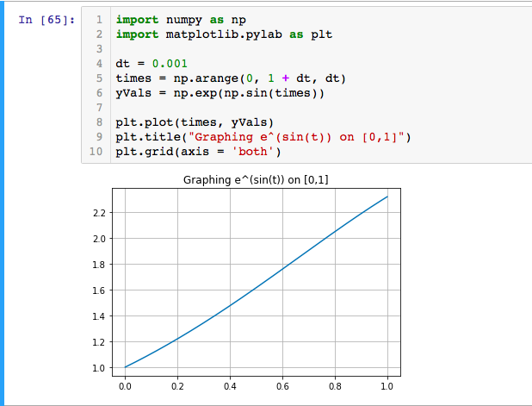

Next, I print the first ten positive integers using a for loop (the HW specification did not specify where to start so I took “first ten integers” to mean the first ten positive integers). range(10) generates a vector of the integers from 0 – 9, and after that I simply print out 1-10 by adding 1 to the current k value and printing.

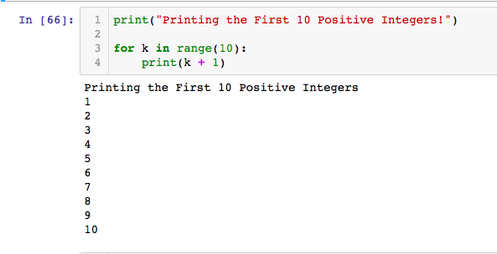

This section focuses on solving a simplified version of the differential equation for voltage in a RC circuit using numerical methods. Scipy.integrate provides access to a collection of tools focused on numerical integration and related tasks. I did not have to re-import numpy or matplotlib.pylab as they were still imported from the previous problems. First, I define my differential equation RCeqn, which is a function of only one variable (V = voltage). No values were given for the resistance or capacitance, so I arbitrary chose R = 1 and C = 1 (lines 3-8). Next, I define my initial conditions, V(0) = 1, and solve the ordinary differential equation numerically using odeint (lines 10-13). Odeint returns a vector of voltage values over time, and I plot these voltages versus the time points used to generate them with matplotlib.pylab (plt; lines 14-18). As we see in the graph, the voltage deteriorates exponentially over time, which we would expect as there is no input current. The exponential decay is so rapid in this case as the time constant, tau = R\*C, for this system is so small.

